|  |  |  |
| --- | --- | --- |
|  |  | |
| C:\Users\kperrin\Desktop\May 2017\P1030526.JPG |  | **Alexandria Arlington**  **Resource Recovery Facility**  Fiscal Year 2017  Annual Operations Report  **August 2017** |
| C:\Users\kperrin\Desktop\May 2017\P1030545.JPG |  |
| **Prepared by:**  **HDR Engineering, Inc.**  **5426 Bay Center Drive, Suite 400**  **Tampa, Florida 33609-3444** | C:\Users\kperrin\Desktop\May 2017\P1030488.JPG | |
|  |  | |

Table of Contents

Section No. Page No.

1.0 Purpose of Report 4

2.0 Executive Summary 4

3.0 Facility Inspection and Records Review 6

4.0 Facility Performance 10

4.1 Utility and Reagent Consumptions 25

4.2 Safety & Environmental Training 26

5.0 Facility Maintenance 28

5.1 Availability 28

5.2 Downtime Summary 30

5.3 Facility Housekeeping 31

6.0 Environmental 32

6.1 Nitrogen Oxide Emissions 32

6.2 Sulfur Dioxide Emissions 32

6.3 Carbon Monoxide Emissions 33

6.4 Opacity 33

6.5 Daily Emissions Data 33

6.6 2017 Annual Stack Testing 33

6.7 Ash System Compliance 36

APPENDIX A FACILITY CEMS DATA 38

APPENDIX B PHOTOS 42

**Front Cover Photos**

**Top:** General Facility Photo from up Eisenhower

**Middle:** Administration Building Receptionist Area Lobby – Renovations Complete

**Bottom:** SDA Hopper Nos. 2 and 3 from Economizer Deck

List of Tables

Table No. Page No.

Table 1: Summary of Inspection Report Deficiencies 8

Table 2: Quarterly Performance Summaries 18

Table 3: Waste Delivery Classification 19

Table 4: Facility Utility and Reagent Consumptions 25

Table 5: Quarterly Facility Unit Availabilities 29

Table 6: Boiler Downtime – Q4FY17 30

Table 7: Turbine Generator Downtime – Q4FY17 30

Table 8: Facility Housekeeping Ratings – May 2017 31

Table 9: Stack Test Results through 2017 35

Table 10: Comparison of Statistical Results and Regulatory Thresholds for Metal Analytes 36

Table 11: Unit #1 Monthly Summary for Reportable Emissions Data 39

Table 12: Unit #2 Monthly Summary for Reportable Emissions Data 40

Table 13: Unit #3 Monthly Summary for Reportable Emissions Data 41

List of Charts

Chart No. Page No.

Chart 1: Tons of Waste Processed 11

Chart 2: Tons of Ash Produced per Ton of Waste Processed 12

Chart 3: Ferrous Recovery Rate 13

Chart 4: Steam Production 14

Chart 5: 12-Month Rolling Steam Production 15

Chart 6: Steam Production Rate 16

Chart 7: Calculated Waste Heating Value 17

Chart 8: Cumulative Total Waste Delivery 20

Chart 9: Gross Electrical Generation 20

Chart 10: Gross Conversion Rate 21

Chart 11: Net Conversion Rate 22

Chart 12: Net Conversion Rate 23

Chart 13: Gross Turbine Generator Conversion Rate 24

Chart 14: Net Turbine Generator Conversion Rate 25

Chart 15: Stack Test Results through 2017 34

Chart 16: Ash Toxicity Characteristic Leaching Procedure (TCLP) Results 36

Chart 17: Quarterly Ash Test Results 37

List of Figures

Figure No. Page No.

Figure 1: Ceiling panels deteriorated above Boiler Nos. 2 and 3 – New Deficiency 43

Figure 2: Pebble Lime Warning Sign deteriorated on SDA No. 3 Entrance Door – New Deficiency 43

Figure 3: Fence falling over near Citizen’s Drop Roll-Off – New Deficiency 43

Figure 4: Siding on north and east side of Facility dirty – New Deficiency 43

Figure 5: Viewport glass cracked on Boiler No. 3 Barn Door – New Deficiency 43

Figure 6: Cooling Towers & Ash Trailer Canopy from SDA Deck No. 3 43

Figure 7: SDA No. 3 and Dolomitic Lime Silo 44

Figure 8: Scales and Facility Roadway from Turbine Generator Enclosure Roof 44

Figure 9: SDA Hopper Nos. 2 and 3 from Economizer Deck 44

Figure 10: Turbine Generator No. 2 44

Figure 11: Ferrous Magnet 44

Figure 12: Ammonia Storage Silo 44

Figure 13: Cooling Tower and Stack 45

Figure 14: White Goods Roll-off 45

Figure 15: Tipping Floor Entrance Road 45

Figure 16: Scales and Scale House 45

Figure 17: Citizen’s Drop off Roll-off 45

Figure 18: South side of Facility from Eisenhower Sidewalk 45

Figure 19: West side Roadway from Facility Entrance 46

Figure 20: General Facility Photo from southeast up Eisenhower 46

Figure 21: TCLP Sampling in Progress 46

Figure 22: Baghouse Aisle – No issues observed 46

Figure 23: SDA Hopper Double Dump Valve 46

Figure 24: Facility Upgrades – New Lighting, Floor Tiles, and Paint 46

Figure 25: Facility Upgrades – Covanta Break Room with New Floor Tiles and Paint 47

Figure 26: Facility Upgrades - New Concrete Slab at Facility Entrance 47

Figure 27: Facility Upgrades – Receptionist Area - New Lighting, Floor Tiles, Ceiling Tiles and Paint 47

Figure 28: Facility Upgrades – New Conference Room just off Main Entrance 47

Figure 29: Facility Upgrades – Receptionist Area – Alternate View 47

Figure 30: New LED Light Fixtures throughout Turbine Generator Enclosure 47

**Definition of Abbreviations & Acronyms**

|  |  |
| --- | --- |
| Abbreviation/Acronym | Definition |
| APC | Air Pollution Control |
| Apr | April |
| Aug | August |
| Avg | Average |
| Btu | British thermal unit |
| CAAI | Covanta Alexandria Arlington, Inc. |
| CEMS | Continuous Emissions Monitoring System |
| CO | Carbon Monoxide |
| Dec | December |
| ECOM | Emergency Communications |
| Feb | February |
| FMG | Facility Monitoring Group |
| FY | Fiscal Year |
| gal | Gallon |
| GAT | Guaranteed Annual Tonnage |
| HCl | Hydrochloric (Hydrogen Chlorides) |
| HDR | HDR Engineering Inc |
| HHV | Estimated Waste Heating Value (Btu/lb) |
| ID | Induced Draft |
| Jan | January |
| Jul | July |
| Jun | June |
| klbs | Kilo-pounds (1,000 lbs) |
| kWhr | Kilowatt hours (1,000 watt-hours) |
| lbs | Pounds |
| LOA | Letter of Agreement |
| Mar | March |
| Max | Maximum |
| May | May |
| Min | Minimum |
| MSW | Municipal Solid Waste |
| MWhr | Megawatt hours |
| No | Number |
| NOV | Notice of Violation |
| Nov | November |
| NOx | Nitrogen Oxide |
| Oct | October |
| OSHA | Occupational Safety and Health Administration |
| PDS | Potomac Disposal Services |
| ppm | Parts per million |
| ppmdv | Parts per million dry volume |
| PSD | Prevention of Significant Deterioration |
| Q1 | First Quarter |
| Q2 | Second Quarter |
| Q3 | Third Quarter |
| Q4 | Fourth Quarter |
| RE | Reportable Exempt |
| RNE | Reportable Non-Exempt |
| SDA | Spray Dryer Absorber |
| Sep | September |
| SO2 | Sulfur Dioxide |
| TCLP | Toxicity Characteristic Leaching Procedure |
| VADEQ | Virginia Department of Environmental Quality |
| WL | Warning Letter |
| yr | Year |
| YTD | Year to date |

Alexandria/Arlington Waste-to-Energy Facility

Annual Operations Report – Fiscal Year 2017

# Purpose of Report

HDR Engineering, Inc. (HDR) was authorized by the Facility Monitoring Group (FMG) to conduct quarterly inspections and provide quarterly reports regarding the operation and maintenance of the Covanta Alexandria/Arlington Waste-to-Energy Facility (Facility) for the 2017 calendar year. This report is prepared for the fourth quarter of the 2017 fiscal year and summarizes Facility operations between April 1, 2017 and June 30, 2017, as well as the entire fiscal year. This report identifies the fiscal year beginning on July 1, 2016 as FY17 and the quarter beginning on April 1, 2017 as Q4FY17.

This report is based upon HDR’s experience in the waste-to-energy industry, upon site observation visits and previous reports provided by HDR, and upon data provided by Covanta Alexandria / Arlington, Inc. (CAAI), the Facility owner and operator.

# Executive Summary

CAAI operated the Facility in an acceptable manner and in accordance with established waste-to-energy industry practices during Q4FY17. The operation of the Facility, maintenance, safety, and overall cleanliness continue to be above average. Environmental performance was excellent with no reportable environmental excursions throughout the quarter. Note that as of June 30, 2017, the CAAI Facility has operated 1,296 days without an environmental excursion.

During Q4FY17, the boilers experienced four (4) instances of unscheduled downtime totaling 52.1 hours, and the turbine generators experienced no unscheduled downtime. Boiler No. 2 experienced one (1) instance of scheduled downtime totaling 17.8 hours for routine cleaning during Q4FY17. During the quarter, the boilers experienced no standby time, and Turbine Generator No. 2 experienced 7.3 hours of standby time while Boiler No. 2 was down. Note that standby time is not factored into overall availability. A detailed listing of downtime is provided in Section 5.2 of this report.

Average waste processed during the quarter was 1,022.2 tons per day, or 104.8% of nominal facility capacity. Waste deliveries averaged 1,036.4 tons per day, which is 1.4% higher than the burn rate. The capacity utilization of 104.8% is comparable to that of mature, well run waste to energy facilities.

For FY17, average waste processed was 957.6 tons per day, or 98.2% of nominal facility capacity of 975 tons per day. Waste deliveries averaged 955.1 tons per day, which is 0.3% less than the annual burn rate. The annual capacity utilization of 98.2% compares very favorably to industry averages.

Performance trends for various measurements are presented in Section 4. In general, the Facility continues to demonstrate reasonable consistency in month to month performance throughout the most recent three-year period tracked for detailed comparisons.

During the quarter, MSW processed slightly increased (0.7%) from the corresponding quarter in FY16; steam production increased (1.1%), and electricity generated (gross) increased (0.9%) from the corresponding quarter in FY16. The increase in steam generation is attributable to the increase (1.4%) in waste heating value, offset by more boiler downtime (14.4 additional hours). The increase in electricity generated (gross) in Q4FY17, is attributable to higher steam production, offset by slightly more downtime (0.6 additional hours) experienced by the turbine generators.

During FY17, MSW processed slightly decreased 0.1% from FY16; steam production slightly increased 0.1%, and electricity generated (gross) increased 1.5% compared to FY16. The increase in steam generation was attributable to the increase (1.8%) in the calculated average waste heating value, offset by more (117.3 additional, hours) scheduled, unscheduled, and standby downtime experienced by the boilers. The increase in gross electrical generation in FY17 as compared to FY16 is attributable to the increase in steam production, offset by more (173.0 additional hours) scheduled, unscheduled, and standby downtime experienced by the turbine generators. Also note that 2016 was a Leap Year and FY16 had an additional day of operations, when compared to the FY17. This negatively biases processed tonnage, steam production, and electrical generation when comparing FY17 to FY16. CAAI continued to throttle back the boiler steam load as necessary in FY17 to stay below the steam production limit.

# Facility Inspection and Records Review

In May 2017, HDR met with the Facility management and other plant personnel to discuss Facility operations and maintenance, acquire data and reports, perform an independent visual inspection of the operating Facility, photograph areas of interest, and perform a review of recent Facility activity. This visit was coordinated with the scheduled FMG meeting. At the time of the inspection, HDR reviewed CAAI records, discussed performance issues with CAAI staff, and provided a verbal report and performance statistics at the May 2017 FMG meeting. HDR maintains a running tabulation of the status of corrective actions and plant performance trends. CAAI provides the following documents for each month:

* Facility Monthly Operating Reports
* Monthly Continuous Emissions Monitoring System (CEMS) Reports

Table 1 summarizes maintenance, repair, and plant condition issues reported during this and prior reporting periods. An “A” indicates an issue of the highest priority and worthy of immediate attention. Such items are usually safety or operability issues. A “B” indicates that the issue needs to be dealt with as quickly as possible, but is not urgent. These items will usually result in a process improvement or will help avoid future “urgent” issues. A “C” indicates that the issue should be dealt with at the earliest convenience, but is not a priority issue. This category might include issues related to aesthetics, non-urgent maintenance, or housekeeping improvements which are not safety related.

Note that HDR inspections are generally performed while equipment is operating, and are not intended to address the internal condition, performance or life expectancy of mechanical, electrical and electronic equipment and structures. HDR inspections are only performed quarterly, generally representing findings on the day of the inspection. CAAI is responsible, without limitation, for operations, maintenance, environmental performance and safety and should not rely on HDR observations or inspection reports which are overviews of Facility external conditions only.

Table 1: Summary of Inspection Report Deficiencies

*A is highest priority & demands immediate attention: B needs attention, but is not urgent; C can be addressed at earliest opportunity & is not urgent.

| Item No. | Inspection Report Deficiencies | Issue Reported | Priority* | HDR Recommendation | Status | Open / Closed |
| --- | --- | --- | --- | --- | --- | --- |
| 1 | Corrosion on ceiling panels in Turbine Generator Enclosure | August 2014 | C | Sand, Prime, Paint and Preserve, and replace deteriorated panels as necessary | **HDR observed the corroded/deteriorated sections had been primed, but no panels were replaced. CAAI reports that it plans to replace panels in 1 to 2 years.** | Open |
| 2 | Deteriorated purlin east wall in Tipping Floor Enclosure | November 2014 | C | Replace deteriorated purlin | **CAAI reports that it will replace sections of the east wall of the Tipping Floor Enclosure as a 2016 Budget Item.** | Open |
| 3 | Induced Draft Fan No. 1 Lagging deteriorated, west side of CEMS Enclosure | May 2015 | C | Replace deteriorated Induced Draft Fan Lagging | **Status Unchanged** | Open |
| 4 | Pot hole, southeast corner of Ash Trailer Canopy | August 2015 | C | Repair road surface | **Status Unchanged** | Open |
| 5 | Chemical storage container deteriorated, north of Main Vibrating Pan, at ground elevation | February 2016 | C | Replace storage container | **Complete** | Closed |
| 6 | Underside of grating deteriorated, upper elevations of all three economizers | August 2016 | C | Replace economizer grating in upper elevations | **Status Unchanged** | Open |
| 7 | Pavement spider-cracking at Tipping Floor Entrance | November 2016 | C | Resurface section of pavement at Tipping Floor Entrance | **Status Unchanged** | Open |
| 8 | Concrete slab damaged that Citizen’s Drop-off Roll-off is on | November 2016 | C | Repair concrete slab | **Status Unchanged** | Open |
| 9 | Pothole where Tipping Floor Exit Road enters Eisenhower Avenue | November 2016 | C | Repair pothole | **Complete** | Closed |
| 10 | Corrosion on Scale House | November 2016 | C | Conduct proper painting preservation measures on corroded spots of Scale House | **Status Unchanged** | Open |
| 11 | Housing Damaged of Self Contained Breathing Apparatus (SCBA) – North Charging Floor Entrance | February 2017 | C | Replace SCBA Enclosure | **Complete** | Closed |
| 12 | Tipping Floor Center Bay concrete apron eroded and rebar exposed | February 2017 | C | Resurface eroded section of Tipping Floor near refuse pit | **Status Unchanged** | Open |
| 13 | Ceiling panels deteriorated above Boiler Nos. 2 and 3–– See Figure 1 (Appendix B) | May 2017 | C | Replace deteriorated ceiling tiles and conduct painting preservation measures | **Status Unchanged** | Open |
| 14 | Pebble Lime Warning Sign deteriorated on SDA No. 3 Entrance Door –– See Figure 2 (Appendix B) | May 2017 | A | Replace sign | **Status Unchanged** | Open |
| 15 | Fence falling over near Citizen’s Drop Roll-Off –– See Figure 3 (Appendix B) | May 2017 | C | Re-align and secure fence | **Status Unchanged** | Open |
| 16 | Siding on north and east side of Facility dirty –– See Figure 4 (Appendix B) | May 2017 | C | Pressure Wash Siding | **Status Unchanged** | Open |
| 17 | Viewport glass cracked on Boiler No. 3 Barn Door –– See Figure 5 (Appendix B) | May 2017 | A | Replace viewport glass | **Status Unchanged** | Open |

# Facility Performance

Monthly operating data provided by CAAI indicates that 93,024 tons of MSW were processed during Q4FY17, and a total of 94,315 tons of MSW including 4,842 tons of Special Handling Waste were received. Total ash production during the quarter was 18,451 tons, which represents 19.8% of the waste processed by weight. The average uncorrected steam production rate for Q4FY17 was 3.04 tonssteam/tonwaste, which is higher (1.8%) than the corresponding quarter in FY16. The increase in this metric is attributable to the 1.4% increase in the average waste heating value (HHV) calculated by CAAI.

On an annual basis, 349,516 tons of MSW were processed during FY17, and a total of 348,616 tons of MSW and 13,411 tons of Special Handling Waste were received. Total ash production during FY17 was 71,208 tons, which represents 20.4% of the waste processed. The average uncorrected steam production rate for FY17 was 3.0 tonssteam/tonwaste, and slightly higher (0.2%) than the corresponding period last year. The slight increase in this metric is attributable to the increase (1.8%) in the calculated average waste heating value that was experienced in FY17, as compared to FY16.

Chart 1: Tons of Waste Processed

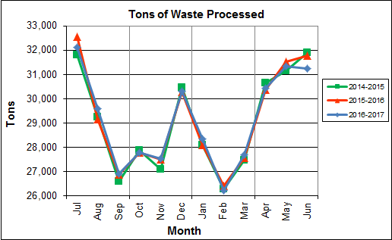

Chart 1 illustrates that Q4FY17 waste processed was slightly lower (0.7%) than the corresponding quarter, Q4FY16.

CAAI reported that 457 tipping floor/MSW internal inspections were conducted during the quarter and 10 notices of violation (NOVs) were issued to haulers for the following issues:

* April 2017 – Nine (9) NOVs were issued for:
  + Two (2) NOVs for trash on trucks
  + One (1) NOV for excessive metal in the load
  + One (1) NOV for jumping in line
  + Five (5) for blocking intersection to Tipping Floor
* May 2017 – No NOVs issued
* June 2017 – One (1) NOV issued for excessive metal in the load

Chart 2: Tons of Ash Produced per Ton of Waste Processed

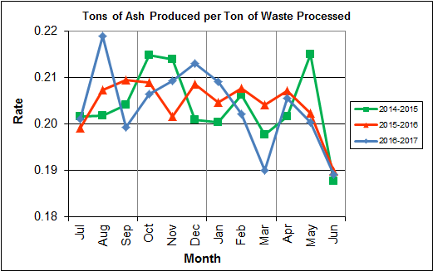

Chart 2 illustrates that the average ash production rate in Q4FY17 was slightly lower (0.2%) at 19.8% of processed waste, compared to the corresponding quarter in FY16 when the rate was 20.0%.

The annual ash production rate for FY17 was identical to FY16 at 20.4%. This result compares very favorably with industry averages which are generally in the range of 25-28%.

Chart 3: Ferrous Recovery Rate

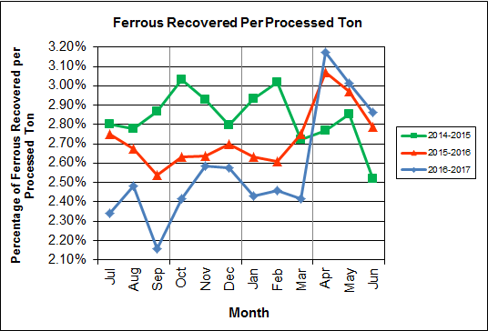

Chart 3 depicts the monthly ferrous metal recovery rate as a percentage of processed MSW tonnage. In Q4FY17, 2,805 tons of ferrous metals were recovered, which is 1.9% higher than the corresponding quarter in FY16 and equivalent to 3.0% of processed waste.

In FY17, 9,036 tons of ferrous metals were recovered, which is 5.6% lower than FY16 and equivalent to 2.6% of processed waste. CAAI attributes the significant decline to an increase in recycling rates resulting in less metal in the MSW. CAAI indicated that in late March 2017, it made adjustments to the length of the main pan to decrease the gap between the pan and the ferrous magnet. The adjustments to the pan resulted in an increased trend in ferrous recovery for the last quarter of FY17.

Chart 4: Steam Production

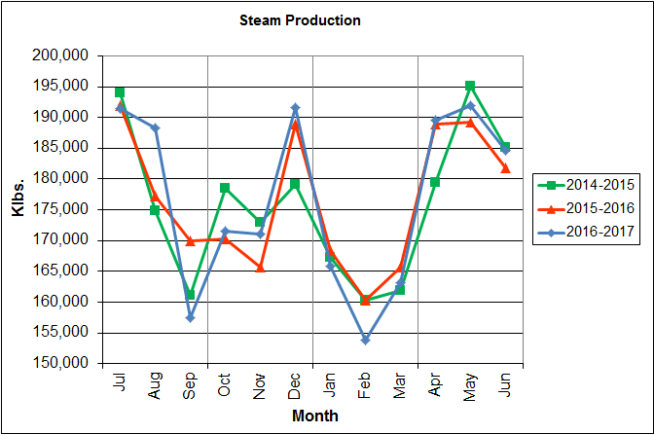

In Chart 4, the total steam production for Q4FY17 was 566,152 klbs., and higher (1.1%) than the corresponding quarter in FY16. The increase in steam generation is attributable to the increase (1.4%) in waste heating value, offset by more boiler downtime (14.4 additional hours).

Annual steam production for FY17 was 2,120,115 klbs., or 0.1% higher than FY16 which produced 2,118,125 klbs. The increase in steam generation was attributable to the increase (1.8%) in the calculated average waste heating value, offset by more (117.3 additional, hours) scheduled, unscheduled, and standby downtime experienced by the boilers.

Chart 5: 12-Month Rolling Steam Production

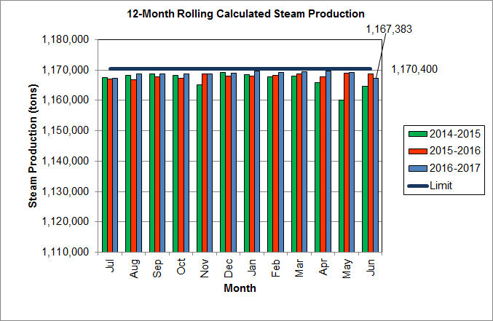

Chart 5 depicts the 12-month rolling steam production total for the period ending in June 2017. According to the Title V permit, the annual steam production for the Facility shall not exceed 1,170,400 tons on the basis of an average value of 3.34 lbs of steam per lb of MSW processed, calculated monthly as the sum of each consecutive 12 month period. The Facility was in compliance with the 12-month rolling steam production total every month in FY17. The 12-month rolling total for steam production ending in June 2017 was 1,167,383 tons which is 99.7% of the limit. Chart 5 clearly shows that Facility throughput, and in turn, steam and electricity production are being throttled to stay ever so slightly below the steam production limit nearly every month.

Chart 6: Steam Production Rate

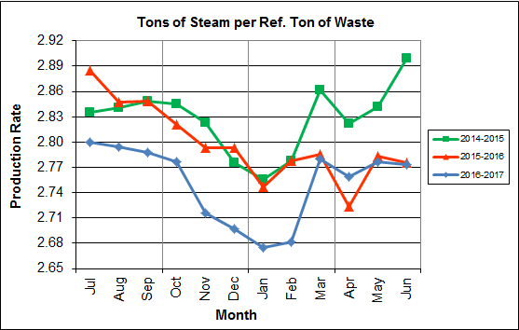\

In Chart 6, the conversion of raw waste tonnages into “reference tons” is another way of analyzing steam production, and helps to determine whether changes are related to boiler performance or to fuel issues. “Reference tons” are adjusted to account for the calculated average fuel heating value, so that lower Btu fuel raw tonnages are adjusted upwards and vice versa. In Q4FY17, this metric tracked slightly higher (0.3%) at 2.77 tonssteam/tonref,, compared to the corresponding quarter in FY16. This trend shows a very slight improvement of boiler performance compared to the prior three (3) quarters in FY17, but still significantly lower than two (2) years ago.

The annual steam production rate for FY17 was 2.75 tonssteam/tonref, which is lower (1.6%) than FY16. This chart shows that for the last first eight (8) months of FY17, a downtrend was experienced in the normalized steam production rate compared to the same period during the prior two (2) years. Although an improvement was experienced during Q4FY17, this trend should continue to be monitored to determine if it is indicative of poorer boiler performance, an aberration during scheduled outage periods, or some other currently unexplained cause.

Chart 7: Calculated Waste Heating Value

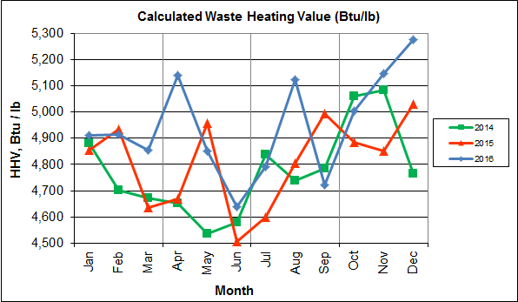

Chart 7 illustrates that Q4FY17 calculated average waste heating value was higher (1.4%) at 4,946 Btu/lb than the corresponding quarter Q4FY16, which averaged 4,877 Btu/lb.

In FY17, the annual average waste heating value was higher (1.8%) at 4,959 Btu/lb than FY16, which averaged 4,873 Btu/lb. Note that the FY17 annual average heating value of 4,959 Btu/lb is 10.2% higher than the facility design value of 4,500 Btu/lb. This disparity in average heating value of the fuel compared to the original design value established in the 1980’s is one of the reasons that the annual capacity utilization is in excess of 100% and considerably higher than similar facilities that generally operate in the 90% range (see Section 2.0).

Table 2: Quarterly Performance Summaries

|  |  |  |  |  |  |  |  |  |
| --- | --- | --- | --- | --- | --- | --- | --- | --- |
| Month | | Waste Processed (tons) | Waste Diverted  (tons) | Ash Shipped  (tons) | Special Handling (Supplemental)  (tons) | Ferrous Recovered  (tons) | Steam Produced (klbs) | Net Electrical Generation  (MWhr) |
| **Q4FY15** | **Quarterly Totals** | **93,695** | **0** | **18,870** | **1,842** | **2,541** | **559,721** | **36,175** |
| April -15 | 30,646 | 0 | 6,182 | 613 | 848 | 179,434 | 12,784 |
| May -15 | 31,160 | 0 | 6,701 | 531 | 889 | 195,150 | 11,786 |
| June - 15 | 31,889 | 0 | 5,987 | 698 | 804 | 185,137 | 11,605 |
| **Q4FY16** | **Quarterly Totals** | **93,652** | **0** | **18,703** | **2,262** | **2,753** | **559,883** | **40,207** |
| April -16 | 30,356 | 0 | 6,289 | 996 | 932 | 188,882 | 13,853 |
| May -16 | 31,530 | 0 | 6,380 | 605 | 936 | 189,239 | 13,541 |
| June – 16 | 31,766 | 0 | 6,034 | 661 | 885 | 181,762 | 12,813 |
| **Q4FY17** | **Quarterly Totals** | **93,024** | **0** | **18,451** | **4,842** | **2,805** | **566,152** | **40,625** |
| April -17 | 30,423 | 0 | 6,255 | 1,420 | 966 | 189,608 | 13,778 |
| May -17 | 31,350 | 0 | 6,285 | 1,705 | 945 | 191,859 | 13,849 |
| June - 17 | 31,251 | 0 | 5,911 | 1,717 | 894 | 184,685 | 12,998 |
| **FY17 Totals** | | **349,516** | **0** | **71,208** | **13,411** | **9,036** | **2,120,115** | **150,935** |
| **FY16 Totals** | | **349,881** | **0** | **71,401** | **8,567** | **9,571** | **2,118,125** | **148,529** |
| **FY15 Totals** | | **348,686** | **0** | **71,019** | **5,413** | **9,864** | **2,109,442** | **145,085** |

Table 2 presents the production data provided to HDR by CAAI for Q4FY17 on both a monthly and quarterly basis. For purposes of comparison, data for Q4FY15 and Q4FY16 are also shown, as well as FY15, FY16 and FY17 totals.

In comparing quarterly totals, the data shows:

* Less waste was processed in Q4FY17 than Q4FY16 and Q4FY15
* More steam was generated in Q4FY17 than Q4FY16 and Q4FY15
* More electricity was generated in Q4FY17 than Q4FY16 and Q4FY15
* Significantly more supplemental waste was received in Q4FY17 than Q4FY16 and Q4FY15.

Please note that the total steam generation figures presented in Table 2 do not correlate with the annual steam production limit from the Facility Permit; such limits apply on a rolling average monthly basis, and not a fiscal year basis. It is also worth noting that the quantity of waste processed during Q4FY17 continues to be limited by the steam production permit restrictions (refer to Chart 5).

Table 3: Waste Delivery Classification

|  |  |  |  |  |  |  |  |  |  |  |  |  |  |  |  |
| --- | --- | --- | --- | --- | --- | --- | --- | --- | --- | --- | --- | --- | --- | --- | --- |
|  |  | **Jul** | **Aug** | **Sep** | **Oct** | **Nov** | **Dec** | **Jan** | **Feb** | **Mar** | **Apr** | **May** | **Jun** | **Totals** | **% of Total** |
| **FY13** | **Jurisdiction Waste** | 19,413 | 18,357 | 16,632 | 17,625 | 18,838 | 16,195 | **-** | **-** | **-** | **-** | **-** | **-** | 107,058 | 30.76% |
| **Spot Waste tons** | 10,516 | 11,326 | 10,610 | 10,317 | 9,330 | 9,558 | **-** | **-** | **-** | **-** | **-** | **-** | 61,656 | 17.72% |
| **City Waste** | **-** | **-** | **-** | **-** | **-** | **-** | 1,683(1) | 1,287 | 1,444 | 2,382 | 2,286 | 1,919 | 11,000 | 3.16% |
| **County Waste** | **-** | **-** | **-** | **-** | **-** | **-** | 2,442(1) | 2,100 | 2,372 | 3,381 | 3,932 | 3,309 | 17,536 | 5.04% |
| **Municipal Solid Waste** | **-** | **-** | **-** | **-** | **-** | **-** | 25,019(1) | 23,637 | 21,661 | 27,066 | 25,794 | 24,930 | 148,107 | 42.56% |
| **Supplemental Waste** | 151 | 11 | 80 | 25 | 234 | 405 | 363 | 365 | 76 | 403 | 281 | 271 | 2,665 | 0.77% |
| **MSW Totals** | **29,928** | **29,683** | **27,241** | **27,942** | **28,167** | **25,753** | **29,507** | **27,388** | **25,552** | **33,231** | **32,293** | **30,429** | **348,022** | **100.00%** |
|  |  | **Jul** | **Aug** | **Sep** | **Oct** | **Nov** | **Dec** | **Jan** | **Feb** | **Mar** | **Apr** | **May** | **Jun** | **Totals** | **% of Total** |
| **FY14** | **City Waste** | 2,065 | 1,693 | 1,702 | 1,924 | 1,566 | 1,780 | 1,529 | 1,231 | 1,556 | 2,256 | 2,203 | 1,883 | 21,389 | 6.11% |
| **County Waste** | 3,459 | 3,079 | 2,784 | 3,091 | 2,707 | 2,802 | 2,568 | 1,957 | 2,272 | 3,326 | 3,987 | 3,387 | 35,419 | 10.12% |
| **Municipal Solid Waste** | 26,167 | 23,604 | 22,034 | 23,354 | 21,879 | 25,531 | 23,869 | 22,523 | 23,198 | 25,414 | 27,206 | 24,812 | 289,590 | 82.75% |
| **Supplemental Waste** | 546 | 676 | 248 | 410 | 188 | 268 | 275 | 192 | 231 | 253 | 151 | 110 | 3,548 | 1.01% |
| **MSW Totals** | **32,237** | **29,053** | **26,768** | **28,779** | **26,340** | **30,380** | **28,241** | **25,903** | **27,256** | **31,249** | **33,546** | **30,193** | **349,946** | **100.00%** |
|  |  | **Jul** | **Aug** | **Sep** | **Oct** | **Nov** | **Dec** | **Jan** | **Feb** | **Mar** | **Apr** | **May** | **Jun** | **Totals** | **% of Total** |
| **FY15** | **City Waste** | 1,814 | 1,497 | 1,699 | 1,737 | 1,518 | 1,770 | 1,411 | 1,209 | 1,648 | 2,155 | 2,059 | 2,045 | 20,562 | 5.91% |
| **County Waste** | 3,297 | 2,868 | 2,973 | 3,095 | 2,508 | 2,852 | 2,358 | 1,833 | 2,411 | 3,269 | 3,652 | 3,572 | 34,687 | 9.96% |
| **Municipal Solid Waste** | 26,661 | 24,466 | 21,887 | 21,241 | 21,678 | 27,906 | 24,611 | 20,915 | 24,094 | 25,189 | 23,126 | 25,667 | 287,442 | 82.57% |
| **Supplemental Waste** | 141 | 275 | 329 | 521 | 764 | 529 | 389 | 351 | 272 | 613 | 531 | 698 | 5,413 | 1.55% |
| **MSW Totals** | **31,913** | **29,106** | **26,888** | **26,595** | **26,468** | **33,057** | **28,769** | **24,308** | **28,424** | **31,225** | **29,369** | **31,982** | **348,105** | **100.00%** |
|  |  | **Jul** | **Aug** | **Sep** | **Oct** | **Nov** | **Dec** | **Jan** | **Feb** | **Mar** | **Apr** | **May** | **Jun** | **Totals** | **% of Total** |
| **FY16** | **City Waste** | 1,960 | 1,563 | 1,723 | 1,645 | 1,685 | 1,872 | 1,147 | 1,619 | 1,811 | 2,024 | 1,950 | 2,220 | 21,219 | 6.03% |
| **County Waste** | 3,627 | 2,880 | 2,832 | 2,869 | 2,682 | 2,891 | 2,025 | 2,389 | 2,694 | 2,406 | 2,508 | 2,661 | 32,465 | 9.22% |
| **Municipal Solid Waste** | 27,933 | 22,999 | 22,552 | 22,850 | 20,679 | 26,138 | 22,632 | 22,781 | 22,935 | 24,388 | 26,561 | 27,355 | 289,801 | 82.32% |
| **Supplemental Waste** | 676 | 427 | 771 | 684 | 676 | 787 | 642 | 850 | 792 | 996 | 605 | 661 | 8,565 | 2.43% |
| **MSW Totals** | **34,196** | **27,869** | **27,878** | **28,047** | **25,722** | **31,687** | **26,446** | **27,639** | **28,232** | **29,814** | **31,623** | **32,896** | **352,049** | **100.00%** |
|  |  | **Jul** | **Aug** | **Sep** | **Oct** | **Nov** | **Dec** | **Jan** | **Feb** | **Mar** | **Apr** | **May** | **Jun** | **Totals** | **% of Total** |
| **FY17** | **City Waste** | 1,678 | 1,836 | 1,668 | 1,722 | 1,817 | 1,708 | 1,597 | 1,452 | 1,604 | 1,882 | 2,170 | 2,002 | 21,136 | 6.06% |
| **County Waste** | 2,386 | 2,469 | 2,370 | 2,184 | 2,321 | 2,289 | 2,287 | 2,016 | 2,517 | 2,371 | 2,877 | 2,889 | 28,976 | 8.31% |
| **Municipal Solid Waste** | 24,862 | 26,976 | 22,760 | 22,110 | 21,598 | 25,996 | 24,218 | 20,888 | 20,401 | 25,004 | 26,143 | 24,135 | 285,091 | 81.78% |
| **Supplemental Waste** | 504 | 642 | 734 | 926 | 941 | 1,036 | 1,083 | 1,413 | 1,291 | 1,420 | 1,705 | 1,717 | 13,412 | 3.85% |
| **MSW Totals** | **29,430** | **31,922** | **27,532** | **26,941** | **26,677** | **31,030** | **29,185** | **25,769** | **25,814** | **30,677** | **32,895** | **30,743** | **348,615** | **100.00%** |
| **Note (1): Beginning January 2013, the method in which waste was classified was modified as compared to prior periods due to change in contractual obligations and plant ownership** | | | | | | | | | | | | | | | |

Chart 8: Cumulative Total Waste Delivery

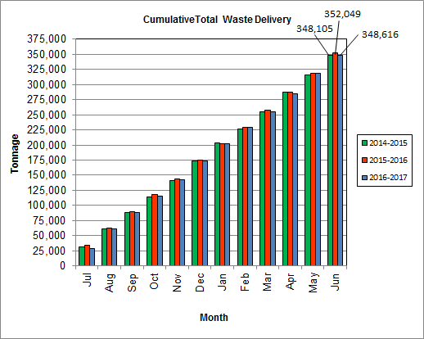

As depicted in Table 3 and Chart 8, for the quarter ending in March 2017; cumulative total waste delivery was 1.0% less compared to the same period in FY16.

Chart 9: Gross Electrical Generation

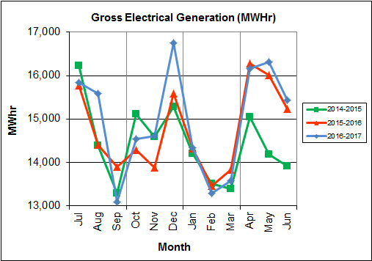

During Q4FY17, the Facility generated 47,923 MWhrs (gross) of electricity compared to Q4FY16 generation of 47,521 MWhrs (gross), a 0.9% increase. The increase in electricity generated (gross) in Q4FY17, is attributable to higher steam production, offset by slightly more downtime (0.6 additional hours) experienced by the turbine generators. Note that the sharp spikes depicted in Chart Nos. 10 through 14 for the months of May and June 2015 are a result of significant downtime (424.7 hours) experienced by Turbine Generator No. 1 to repair an exciter failure.

During FY17, the Facility generated 179,556 MWhrs (gross) of electricity compared to the FY16 generation of 176,967, a 1.5% increase. The increase in gross electrical generation in FY17 as compared to FY16 is attributable to the increase in steam production, offset by more (173.0 additional hours) scheduled, unscheduled, and standby downtime experienced by the turbine generators. Also note that 2016 was a Leap Year and as such had an additional day of operations, when compared to the FY17. This slightly biases negatively processed tonnage, steam production, and electrical generation when comparing FY17 to FY16.

Chart 10: Gross Conversion Rate

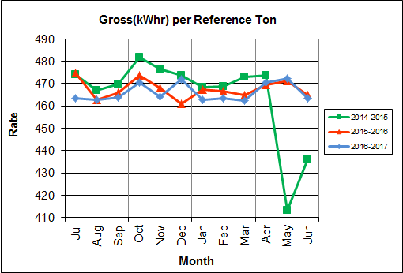

As shown in Chart 10, the average gross electrical generation per reference ton of refuse processed during Q4FY17 was 469 kWhr, which is identical to the corresponding quarter in FY16. Since this calculated value uses reference or normalized tonnages of waste, it should cancel the effect of MSW heating value (Btu content) variability.

During FY17, the average gross electrical generation per reference ton of refuse processed was 466 kWhr, which is slightly lower (0.3%) than FY16.

Chart 11: Net Conversion Rate

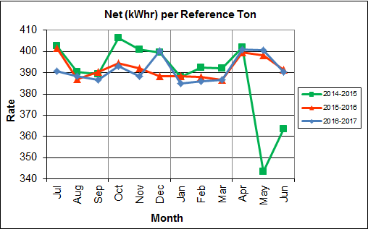

Chart 11 depicts the normalized net power (gross minus in-house usage) generation history. In Q4FY17, the average net electrical generation per reference ton was 397 kWhr, which is 0.3% higher than the corresponding quarter in FY16.

In FY17, the average net electrical generation per reference ton was 391 kWhr, which is 0.2% lower than FY16.

Chart 12: Net Conversion Rate

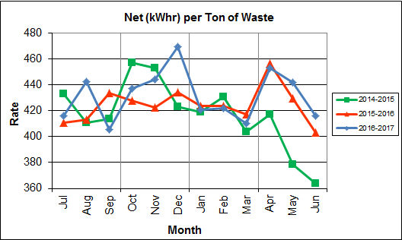

Chart 12 depicts the net power generation per processed ton. The net electrical generation per processed ton in Q4FY17 was 437 kWhr, which is 1.7% higher than the corresponding quarter in FY16, is attributable to higher steam production, offset by slightly more downtime (0.6 additional hours) experienced by the turbine generators.

In FY17, the net electrical generation per processed ton was 432 kWhr which is 1.6% higher than FY16. The increase is attributable to the increase in steam production, offset by more (173.0 additional hours) scheduled, unscheduled, and standby downtime experienced by the turbine generators.

Chart 13: Gross Turbine Generator Conversion Rate

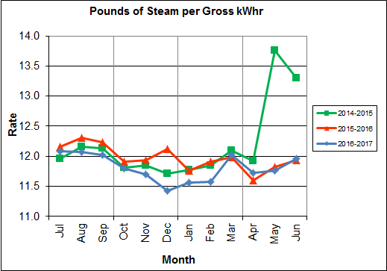

Charts 13 and 14 illustrate the quantities of steam required to generate one (1) kWhr of electricity, gross and net respectively. This measure is a turbine generator performance indicator, where lower steam rates indicate superior performance. For simplification, this calculated rate is based on the average for the two turbine generators. In Q4FY17 the average lbs of steam consumed per gross kWhr generated was 11.8, which is 0.3% higher (less efficient) than the corresponding quarter Q4FY16. A factor that negatively impacts this metric is Turbine Generator No. 2, which continues to operate with its Stage 9 blades removed from the rotor. CAAI reported that during the Turbine Generator No. 2 overhaul in November 2013, some cracking was observed on the Stage 9 blades of the rotor, and the blading in that row was removed as a precautionary measure. CAAI originally indicated that a new set of blades would be manufactured and installed during a Turbine Generator No. 2 Outage in 2016, but advised in May 2015, that the implementation of the replacement blades installation would be delayed, and did not provide a date for repair. The average lbs of steam consumed per net kWhr was 13.9, which is 0.1% higher (declined) than the corresponding quarter in FY16. The average steam temperature during the quarter was 691.3° F, which is 0.1% higher than the average steam temperature of the corresponding quarter last fiscal year and 8.7° F lower than design temperature of 700o F.

In FY17, the average lbs of steam consumed per gross kWhr was 11.8, which is 1.4% lower than the rate in FY16, noting that for this metric, lower steam consumption represents improved performance. The average lbs of steam consumed per net kWhr in FY17 was 14.1, which is 1.5% lower than the rate in FY16. The average steam temperature for FY17 was 686.4o F, which is slightly higher (0.9%) than the steam temperature in FY16 and 13.6F lower than the design temperature of 700o F.

Chart 14: Net Turbine Generator Conversion Rate

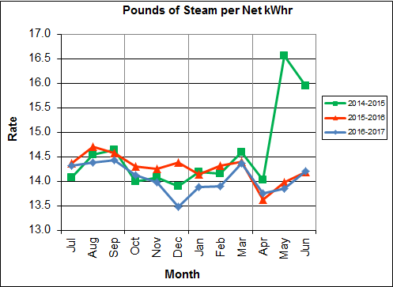

## Utility and Reagent Consumptions

Table 4: Facility Utility and Reagent Consumptions

|  |  |  |  |  |  |  |  |
| --- | --- | --- | --- | --- | --- | --- | --- |
| **Utility** | **Units** | **Q4FY17 Total** | **Q4FY16**  **Total** | **Q4FY17”Per Processed Ton” Consumption** | **Q4FY16”Per Processed Ton” Consumption** | **FY17**  **Total** | **FY16**  **Total** |
| **Purchased Power** | MWhr | 6,191 | 5,651 | 0.07 | 0.06 | 22,906 | 22,242 |
| **Fuel Oil** | Gal. | 13,440 | 11,590 | 0.14 | 0.12 | 58,890 | 41,110 |
| **Boiler Make-up** | Gal. | 1,234,000 | 1,794,000 | 13.27 | 19.16 | 6,257,000 | 7,813,000 |
| **Cooling Tower Make-up** | Gal. | 42,298,090 | 42,074,659 | 454.70 | 449.27 | 152,993,251 | 146,912,669 |
| **Pebble Lime** | Lbs. | 1,324,000 | 1,344,000 | 14.23 | 14.35 | 5,042,000 | 5,378,000 |
| **Ammonia** | Lbs. | 191,000 | 183,000 | 2.05 | 1.95 | 710,000 | 663,000 |
| **Carbon** | Lbs. | 94,000 | 98,000 | 1.01 | 1.05 | 374,000 | 404,000 |
| **Dolomitic Lime** | Lbs. | 290,000 | 138,000 | 3.12 | 1.47 | 784,000 | 701,800 |

Fuel oil usage during the quarter represents approximately 0.22% of the total heat input to the boilers, which compares favorably with industry averages, and slightly higher than the percentage of heat input in Q4FY16 which was 0.19%. Fuel oil is used to stabilize combustion of wet fuel, as well as during start-up and shut-down of the boilers for maintenance. Boiler makeup water usage during the quarter represents 1.8% of steam flow, which is slightly lower than the boiler makeup in Q4FY16 which was 2.7%, and is acceptable. Pebble lime usage, at 1,324,000 lbs. is lower (1.5%) than the corresponding quarter last year, and the quarterly consumption rate of 14.2 lbs/ton is below historical levels (16-18 lbs/ton).

In comparing Q4FY17 to Q4FY16 on a per processed ton consumption basis:

* the purchased power consumption rate was 10.3% higher
* the total fuel oil consumption rate was 16.7% higher
* the boiler make-up water consumption rate was 30.8% lower
* the cooling tower make-up water consumption rate was 1.2% higher
* the total pebble lime consumption rate was 0.8% lower
* the ammonia consumption rate was 5.1% higher
* the carbon consumption rate was 3.4% lower
* the total dolomitic lime consumption rate was 111.6% higher

CAAI reports that the significant increase in dolomitic lime usage during the quarter, when compared to the corresponding quarter last year, is attributable to a dolomitic lime silo level detector malfunction experienced from June 25, 2015 through July 9, 2015.  As a result of this malfunction, CAAI stated that delivery totals were utilized as usage totals during those months last fiscal year.

## Safety & Environmental Training

The Facility experienced no OSHA recordable accidents during the quarter and has operated 284 days without an OSHA recordable accident. During the quarter, Safety and Environmental training was conducted with themes as follows:

**April 2017**

* Safety:
  + Blood Borne Pathogens
  + Hearing Conservation
  + Barricades and Flagging
* Environmental:
  + Reagent Optimization

**May 2017**

* Safety:
  + Walking, Working Surfaces, and Fall Protection
  + Fall Protection Equipment and Inspection
  + Portable Ladder Safety
  + Fall Hazards
  + Inspections and Assessments
* Environmental:
  + Annual Review of the Environmental Compliance Operating Manual (ECOM)
  + Exercise on procedure if an unknown chemical is delivered in the waste stream
  + Environmental Awareness and the 3 R’s (Recognize, Report, Respond)

**June 2017**

* Safety:
  + Emergency Action Plan
  + Fire Safety Equipment and Fire Extinguisher Training
  + Heat Stress
  + How to Handle Facility Intruder
* Environmental:
  + Solid Waste Deliveries
  + Environmental Inspections

# Facility Maintenance

Throughout the quarter, significant routine and preventative maintenance was performed. HDR considers that the Facility is implementing an effective maintenance regimen, and is performing routine and preventative maintenance, along with selected equipment replacements in a timely manner. CAAI monthly maintenance reports provide a detailed account of maintenance performed.

Beginning June 21, 2017 Boiler No. 2 experienced 17.8 hours of downtime, for a scheduled cleaning outage. In addition to the scheduled cleaning outage, CAAI reports that 852 preventative maintenance actions were completed during the quarter.

## Availability

Facility availabilities for Q4FY17 are shown in Table 5. According to CAAI reports, the average unit availabilities for Boiler Nos. 1, 2, and 3 for Q4FY17 were 98.6%, 98.2%, and 100.0%, respectively. The three-boiler average availability during the quarter was 98.9%, which is excellent and comparable to that of mature, well run waste to energy facilities.

During Q4FY17, the average availability for Turbine Generator Nos. 1 and 2 was 100.0%, which is excellent.

Overall boiler availability for FY17 was 96.2%, and overall turbine generator availability was 99.5%. Overall availabilities for the boilers are highly acceptable and above industry averages, noting that these reported availability metrics exclude standby time experienced during the fiscal year which amounted to 315.9 hours for the boilers and 631.9 hours for the turbine generators.

Table 5: Quarterly Facility Unit Availabilities

|  |  |  |  |  |  |
| --- | --- | --- | --- | --- | --- |
| **Availability** | **Q1FY17 Average** | **Q2FY17 Average** | **Q3FY17 Average** | **Q4FY17 Average** | **FY17**  **Average** |
| Boiler No. 1 | 97.7% | 97.9% | 91.4% | 98.6% | 96.4% |
| Boiler No. 2 | 94.6% | 99.6% | 90.9% | 98.2% | 95.9% |
| Boiler No. 3 | 98.7% | 94.3% | 92.8% | 100.0% | 96.5% |
| ***Avg.*** | ***97.0%*** | ***97.3%*** | ***91.7%*** | ***98.9%*** | ***96.2%*** |
| Turbine No. 1 | 100.0% | 100.0% | 97.3% | 100.0% | 99.3% |
| Turbine No. 2 | 100.0% | 100.0% | 98.9% | 100.0% | 99.7% |
| ***Avg.*** | ***100.0%*** | ***100.0%*** | ***98.1%*** | ***100.0%*** | ***99.5%*** |

## Downtime Summary

Table 6: Boiler Downtime – Q4FY17

|  |  |  |  |  |  |  |
| --- | --- | --- | --- | --- | --- | --- |
| **Boiler Number** | **Outage Begin Date** | **Outage End Date** | **Hours Unavailable** | | **Downtime**  **Classification** | **Reason Unavailable** |
| 2 | 5/18/17 | 5/18/17 | 21.0 | | Unscheduled | Tube leak repairs |
| 1 | 5/21/17 | 5/21/17 | 3.3 | | Unscheduled | Feeder repairs |
| 1 | 5/28/17 | 5/29/17 | 16.0 | | Unscheduled | Grate bar repairs |
| 1 | 6/6/17 | 6/6/17 | 11.8 | | Unscheduled | Under Fire Air Fan failure |
| 2 | 6/21/17 | 6/21/17 | 17.8 | | Scheduled | Scheduled boiler cleaning |
| **Total Unscheduled Downtime** | | | | **52.1 Hours** | | |
| **Total Scheduled Downtime** | | | | **17.8 Hours** | | |
| **Total Standby Downtime** | | | | **0.0 Hours** | | |
| **Total Downtime** | | | | **69.9 Hours** | | |

Table 7: Turbine Generator Downtime – Q4FY17

| **Turbine Generator Number** | **Outage Begin Date** | **Outage End Date** | **Hours Unavailable** | | **Downtime**  **Classification** | **Reason Unavailable** |
| --- | --- | --- | --- | --- | --- | --- |
| 1 | 6/21/17 | 6/21/17 | 7.3 | | Standby | Scheduled Boiler No. 2 Cleaning |
| **Total Unscheduled Downtime** | | | | **0.0 Hours** | | |
| **Total Scheduled Downtime0** | | | | **0.0 Hours** | | |
| **Total Standby Downtime** | | | | **7.3 Hours** | | |
| **Total Downtime** | | | | **7.3 Hours** | | |

## Facility Housekeeping

CAAI is performing Facility housekeeping and maintaining plant cleanliness in accordance with acceptable industry practices. A site inspection was conducted in May 2017. At the time of the inspection, new deficiencies were recorded and prior deficiencies were given a status update. Photos of interest from the inspection are depicted in Appendix B. The Facility housekeeping ratings from the May 2017 inspection are presented in Table 8.

Table 8: Facility Housekeeping Ratings – May 2017

| **Facility Area** | **Acceptable** | **Needs Improvement** | **Unacceptable** |
| --- | --- | --- | --- |
| **Tipping Floor** | √ |  |  |
| **Citizen’s Drop-off Area** | √ |  |  |
| **Tipping Floor Truck Exit** | √ |  |  |
| **Front Parking Lot** | √ |  |  |
| **Rear Parking Lot** | √ |  |  |
| **Boiler House Pump Room** | √ |  |  |
| **Lime Slurry Pump Room** | √ |  |  |
| **Switchgear Area** | √ |  |  |
| **Ash Load-out Area** | √ |  |  |
| **Vibrating Conveyor Area** | √ |  |  |
| **Ash Discharger Area** | √ |  |  |
| **Cooling Tower Area** | √ |  |  |
| **Truck Scale Area** | √ |  |  |
| **SDA/FF Conveyor Area** | √ |  |  |
| **SDA Penthouses** | √ |  |  |
| **Lime Preparation Area** | √ |  |  |
| **Boiler Drum Levels** | √ |  |  |
| **Turbine Room** | √ |  |  |
| **Electrical Room** | √ |  |  |

# Environmental

The air pollution control equipment maintained emission concentrations well within the established regulations. Average Continuous Emission Monitoring System (CEMS) data collected for each monthly period during Q4FY17 are summarized in Appendix A. No permit deviations were reported by the Facility during Q4FY17. Note that as of June 30, 2017, the CAAI Facility has operated 1,296 days without an environmental excursion.

On August 8, 2014, CAAI sent a letter to the Virginia Department of Environmental Quality (VADEQ) requesting relief from the steam permit limit requirements in the Facility’s Title V and PSD permits. These requested changes relate to the permit values established for the calculated steam-to-waste ratio, which has resulted in a reduction of MSW throughput. In recent discussions, CAAI indicated that it is re-evaluating options to the proposed permit changes, and will provide further updates on this issue.

## Nitrogen Oxide Emissions

During Q4FY17, the monthly emission concentrations of nitrogen oxides (NOx) averaged 160.3 ppmdv, 159.0 ppmdv and 159.3 ppmdv for Boiler Nos. 1, 2, and 3, respectively. CAAI continues to operate the units at the lower (160 ppmdv) set-points, except immediately following a scheduled outage and associated boiler cleaning.

## Sulfur Dioxide Emissions

During Q4FY17 the monthly emission concentration of stack sulfur dioxide (SO2) averaged 1.0 ppmdv, 0.3 ppmdv, and 0.3 ppmdv for Boiler Nos. 1, 2, and 3, respectively. All of these stack SO2 concentrations are significantly below the permit limit of 29 ppmdv @ 7% O2.

## Carbon Monoxide Emissions

During Q4FY17, the average CO emission concentrations on Boiler Nos. 1, 2, and 3 were 35.3 ppmdv, 31.7 ppmdv, and 39.0 ppmdv, respectively, and all are well within permit limits (100 ppmdv, hourly average). However, as reported by HDR during the May 2016 FMG Meeting, and continuing through Q4FY17, CO averages have been trending higher over the past year of operations on all three boilers, and CAAI has been requested to investigate and mitigate this uptrend. While not a permit issue, it is indicative of poorer boiler performance and combustion efficiency.

## Opacity

During Q4FY17, the average opacity for Boiler Nos. 1, 2, and 3 was 0.3%, 1.3%, and 0.3% respectively. All of these averages are significantly below the 10% (6-minute) average permit limit.

## Daily Emissions Data

Appendix A, Tables 11, 12, and 13 tabulate the monthly average, maximum, and minimum emissions data for each unit during Q4FY17. Excursions, if any, would appear in bold print. It should be noted that these tabulations of monthly averages, reported here for informational purposes, are based on tabulations of daily averages. These averages do not correlate with official reports to the regulatory agencies because of differences in averaging times and other technical differences required by agency report formats.

## 2017 Annual Stack Testing

Annual stack testing was conducted March 20th through March 22nd, 2017 by Testar Inc. Historical stack test data including 2017 results are summarized in Chart 15 and Table 9. The 2017 test results demonstrate compliance well within the permit limits for all parameters. In addition to the tests required by the Facility permit, additional tests for small particulate matter (PM < 2.5) were conducted. While there are no current regulatory limits established for PM < 2.5, average results for 2017 were 0.003 Gr/DSCF (grains per dry standard cubic foot) corrected to 7% O­2, compared to the 2016 Annual Stack Testing PM <2.5 Results which averaged 0.005 Gr/DSCF corrected to 7% O­2.

Chart 15: Stack Test Results through 2017

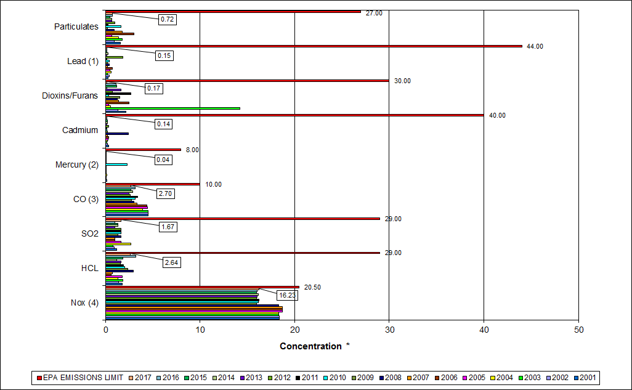

|  |
| --- |
| Note (1): Lead emissions have been decreased by a factor of 10 for trending purposes |
| Note (2): Mercury emissions have been decreased by a factor of 10 for trending purposes |
| Note (3): CO emissions have been decreased by a factor of 10 for trending purposes |
| Note (4): NOx emissions have been decreased by a factor of 10 for trending purposes |

Table 9: Stack Test Results through 2017

|  |  |  |  |  |  |  |  |  |  |  |  |
| --- | --- | --- | --- | --- | --- | --- | --- | --- | --- | --- | --- |
|  |  | **NOx(4)** | **HCL** | **SO2** | **CO(3)** | **Mercury(2)** | **Cadmium** | **Dioxins/Furans** | **Lead(1)** | **Particulates** | **P.M. 2.5** |
|  |  | **(ppmdv)** | **(ppmdv)** | **(ppmdv)** | **(ppmdv)** | **(ug/dscm)** | **(ug/dscm)** | **(ng/dscm)** | **(ug/dscm)** | **(mg/dscm)** | **(gr/dscf)** |
| **2007** | Boiler 1 | 187 | 0.82 | 1 | 31 | 0.38 | 0.25 |  | 2.31 | 2.03 | -- |
| Boiler 2 | 185 | 0.68 | 1 | 36 | 0.39 | 0.19 | 1.42 | 2.12 | 2.04 | -- |
| Boiler 3 | 189 | 0.84 | 1 | 34 | 0.59 | 0.16 |  | 1.55 | 1.33 | -- |
| **AVERAGE** | **187.0** | **0.78** | **1.00** | **33.67** | **0.46** | **0.20** | **1.42** | **1.99** | **1.80** | **--** |
|  |  |  |  |  |  |  |  |  |  |  |  |
| **2008** | Boiler 1 | 181 | 2.96 | 2 | 37 | 0.45 | 6.60 | 1.25 | 9.4 | 1.46 | -- |
| Boiler 2 | 182 | 3.52 | 2 | 30 | 0.42 | 0.50 |  | 2.6 | 0.82 | -- |
| Boiler 3 | 186 | 2.43 | 1 | 24 | 1.03 | 0.16 |  | 0.23 | 0.48 | -- |
| **AVERAGE** | **183.0** | **3.0** | **1.67** | **30.3** | **0.63** | **2.4** | **1.25** | **4.1** | **0.9** | **--** |
|  |  |  |  |  |  |  |  |  |  |  |  |
| **2009** | Boiler 1 | 159 | 1.40 | 2 | 28 | 0.184 | 0.191 |  | 2.260 | 0.483 | -- |
| Boiler 2 | 158 | 2.12 | 1 | 25 | 0.271 | 0.143 |  | 0.894 | 0.068 | -- |
| Boiler 3 | 163 | 3.53 | 1 | 29 | 0.198 | 0.256 | 1.54 | 3.030 | 0.155 | -- |
| **AVERAGE** | **160** | **2.35** | **1.33** | **27.33** | **0.22** | **0.20** | **1.54** | **2.061** | **0.235** | **--** |
|  |  |  |  |  |  |  |  |  |  |  |  |
| **2010** | Boiler 1 | 159 | 2.69 | 1 | 29 | 5.76 | 0.120 |  | 1.33 | 3.690 | 0.00410 |
| Boiler 2 | 158 | 0.67 | 1 | 28 | 29.50 | 0.032 | 0.35 | 3.00 | 0.914 | 0.00630 |
| Boiler 3 | 168 | 2.85 | 3 | 38 | 34.70 | 0.241 |  | 8.71 | 0.336 | 0.00990 |
| **AVERAGE** | **161.7** | **2.07** | **1.67** | **31.67** | **23.32** | **0.13** | **0.35** | **4.347** | **1.647** | **0.007** |
|  |  |  |  |  |  |  |  |  |  |  |  |
| **2011** | Boiler 1 | 167 | 2.15 | 2 | 28 | 0.36 | 0.140 | 2.67 | 1.72 | 0.130 | 0.00570 |
| Boiler 2 | 159 | 1.14 | 1 | 38 | 0.44 | 0.140 |  | 1.46 | 0.350 | 0.00690 |
| Boiler 3 | 161 | 2.40 | 2 | 37 | 0.36 | 0.110 |  | 1.47 | 0.350 | 0.00170 |
| **AVERAGE** | **162.3** | **1.90** | **1.67** | **34.33** | **0.39** | **0.13** | **2.67** | **1.550** | **0.277** | **0.005** |
|  |  |  |  |  |  |  |  |  |  |  |  |
| **2012** | Boiler 1 | 163 | 1.14 | 2 | 23 | 0.30 | 0.310 |  | 1.34 | 0.640 | 0.00932 |
| Boiler 2 | 156 | 2.02 | 2 | 29 | 0.34 | 0.250 | **0.75** | 6.52 | 1.280 | 0.00782 |
| Boiler 3 | 161 | 1.66 | 1 | 27 | 0.37 | 0.590 |  | 47.80 | 1.020 | 0.00679 |
| **AVERAGE** | **160.0** | **1.61** | **1.67** | **26.33** | **0.34** | **0.38** | **0.75** | **18.553** | **0.980** | **0.008** |
|  |  |  |  |  |  |  |  |  |  |  |  |
| **2013** | Boiler 1 | 164 | 1.48 | 1 | 28 | 0.36 | 0.134 |  | 1.45 | 0.637 | 0.00637 |
| Boiler 2 | 158 | 1.98 | 1 | 25 | 0.37 | 0.112 | 1.66 | 1.05 | 0.737 | 0.00475 |
| Boiler 3 | 159 | 1.52 | 1 | 22 | 0.42 | 0.137 |  | 3.03 | 0.733 | 0.00471 |
| **AVERAGE** | **160.3** | **1.66** | **1.00** | **25.00** | **0.38** | **0.13** | **1.66** | **1.843** | **0.702** | **0.005** |
|  |  |  |  |  |  |  |  |  |  |  |  |
| **2014** | Boiler 1 | 167 | 1.13 | 2 | 35 | 0.33 | 0.270 | 0.16 | 3.82 | 0.282 | 0.00337 |
| Boiler 2 | 157 | 1.02 | 1 | 35 | 0.35 | 0.183 |  | 2.52 | 1.240 | 0.00415 |
| Boiler 3 | 161 | 1.50 | 1 | 17 | 0.49 | 0.228 |  | 2.85 | 0.520 | 0.00425 |
| **AVERAGE** | **161.7** | **1.22** | **1.33** | **29.00** | **0.39** | **0.23** | **0.16** | **3.063** | **0.681** | **0.004** |
|  |  |  |  |  |  |  |  |  |  |  |  |
| **2015** | Boiler 1 | 164 | 1.80 | 2 | 25 | 0.32 | 0.102 |  | 1.00 | 0.513 | 0.00540 |
| Boiler 2 | 157 | 1.99 | 1 | 29 | 0.38 | 0.109 |  | 1.30 | 0.532 | 0.00410 |
| Boiler 3 | 159 | 1.71 | 1 | 27 | 0.39 | 0.409 | 1.21 | 3.04 | 0.499 | 0.00074 |
| **AVERAGE** | **160.0** | **1.83** | **1.33** | **27.00** | **0.36** | **0.21** | **1.21** | **1.778** | **0.515** | **0.003** |
|  |  |  |  |  |  |  |  |  |  |  |  |
| **2016** | Boiler 1 | 166 | 4.33 | 1.0 | 29 | 0.46 | 0.231 |  | 2.81 | 1.170 | 0.00680 |
| Boiler 2 | 156 | 3.46 | 1.0 | 37 | 0.43 | 0.154 | 1.16 | 1.13 | 0.657 | 0.00241 |
| Boiler 3 | 159 | 1.86 | 1.0 | 28 | 0.38 | 0.107 |  | 1.59 | 0.371 | 0.00456 |
| **AVERAGE** | **160.3** | **3.22** | **1.00** | **31.33** | **0.42** | **0.16** | **1.16** | **1.843** | **0.733** | **0.005** |
|  |  |  |  |  |  |  |  |  |  |  |  |
| **2017** | Boiler 1 | 171 | 1.41 | 2.0 | 33 | 0.49 | 0.169 | 0.17 | 1.99 | 0.860 | 0.00393 |
| Boiler 2 | 160 | 1.81 | 0.0 | 25 | 0.41 | 0.139 |  | 1.10 | 0.742 | 0.00160 |
| Boiler 3 | 156 | 4.71 | 3.0 | 23 | 0.37 | 0.115 |  | 1.28 | 0.561 | 0.00385 |
| **AVERAGE** | **162.3** | **2.64** | **1.67** | **27.00** | **0.42** | **0.14** | **0.17** | **1.457** | **0.721** | **0.003** |
|  |  |  |  |  |  |  |  |  |  |  |  |
|  | **EPA EMISSIONS LIMIT** | 205 | 29 | 29 | 100 | 80 | 40 | 30 | 440 | 27 | -- |
| **Percent of Limit for 2017** | **79.2%** | **9.1%** | **5.7%** | **27.0%** | **0.5%** | **0.4%** | **0.6%** | **0.3%** | **2.7%** | -- |

## Ash System Compliance

The dolomitic lime feed rate is adjusted periodically in order to maintain a desired ash pH level in the range of 8.0 to 11.0. Since initial startup, the feed rate has varied from between 1 to 9 lbs per ton each month. Ash Toxicity (TCLP) tests were performed for field samples collected over a seven (7) day period in August 2016, and results indicated that the average pH during testing was 8.4. Results from the TCLP testing conducted in May 2017 and August 2016 are depicted in Table 10 and Chart 16 below.

Table 10: Comparison of Statistical Results and Regulatory Thresholds for Metal Analytes

|  |  |  |  |  |  |
| --- | --- | --- | --- | --- | --- |
| **Metals** | **90% Upper Confidence (May 2017)** | **90% Upper Confidence (August 2016)** | **Regulatory Threshold (mg/L)** | **% of Threshold (May 2017)** | **% of Threshold (August 2016)** |
| **Arsenic** | 0.025 | 0.250 | 5.0 | 0.50% | 5.00% |
| **Barium** | 0.912 | 0.805 | 100.0 | 0.91% | 0.81% |
| **Cadmium** | 0.025 | 0.154 | 1.0 | 2.50% | 15.40% |
| **Chromium** | 0.025 | 0.250 | 5.0 | 0.50% | 5.00% |
| **Lead** | 0.025 | 0.250 | 5.0 | 0.50% | 5.00% |
| **Mercury** | 0.0002 | 0.00025 | 0.2 | 0.10% | 0.13% |
| **Selenium** | 0.039 | 0.050 | 1.0 | 3.90% | 5.00% |
| **Silver** | 0.025 | 0.250 | 5.0 | 0.50% | 5.00% |

Chart 16: Ash Toxicity Characteristic Leaching Procedure (TCLP) Results

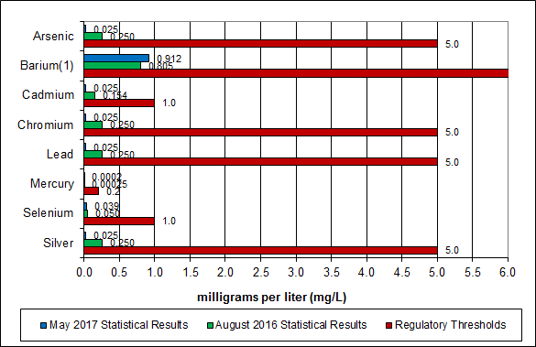

**Note: The regulatory threshold for Barium is 100 mg/L**

CAAI also samples ash monthly in-house, and documents pH reading to adjust dolomitic lime feed rate. The results for the ash pH tests are found below in Chart 17 where each quarter is represented by the average of the respective monthly readings. During Q4FY17, the average ash pH for in-house tests was 9.3.

Chart 17: Quarterly Ash Test Results

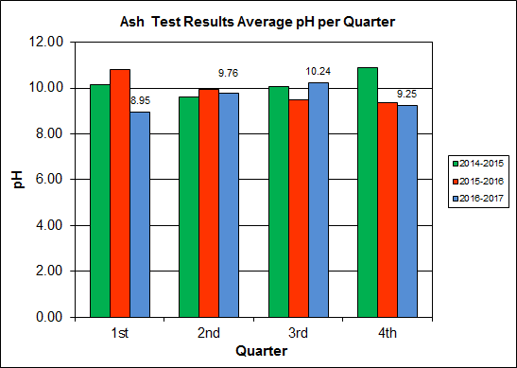

APPENDIX A  
FACILITY CEMS DATA

Table 11: Unit #1 Monthly Summary for Reportable Emissions Data

|  |  |  |  |  |  |  |  |  |  |  |
| --- | --- | --- | --- | --- | --- | --- | --- | --- | --- | --- |
| **Group#-Channel#** | | **G8-C35** | **G8-C28** | **G8-C8** | **G8-C4** | **G8-C12** | **G8-C34** | **G8-C37** | **G8-C40** | **G8-C39** |
| **Long Descrip.** | | **U-1 Steam** | **U-1 Econ** | **U-1 Stack** | **U-1 Stack** | **U-1 Stack** | **U-1 Opaci** | **U-1 FF In** | **U-1 Carbo** | **U-1 Lime** |
| **Short Descrip.** | | **SteamFl** | **SO2ec** | **SO2sc** | **COsc** | **NOxsc** | **Opacity** | **FF InTemp** | **CarbInj** | **LimeFlow** |
| **Units** | | **K#/Hr** | **ppmc** | **ppm** | **ppmc** | **ppmc** | **%** | **deg F** | **#/hr** | **gpm** |
| **Range** | | **0-100** | **0-2000** | **0-500** | **0-4000** | **0-1000** | **0-100** | **100-500** | **0-50** | **0-20** |
| Apr - 17 | AVG | 83.8 | 29.0 | 1.0 | 36.0 | 160.0 | 0.5 | 300.0 | 16.1 | 3.2 |
| Max | 85.6 | 44.0 | 4.0 | 47.0 | 163.0 | 0.9 | 302.0 | 17.2 | 3.3 |
| Min | 82.3 | 20.0 | 0.0 | 25.0 | 156.0 | 0.3 | 300.0 | 16.0 | 2.9 |
| May - 17 | AVG | 83.0 | 23.0 | 1.0 | 35.0 | 160.0 | 0.3 | 300.0 | 15.2 | 3.2 |
| Max | 85.0 | 36.0 | 4.0 | 50.0 | 163.0 | 0.9 | 301.0 | 16.5 | 3.3 |
| Min | 79.2 | 12.0 | 0.0 | 24.0 | 156.0 | 0.0 | 299.0 | 14.9 | 3.1 |
| Jun - 17 | AVG | 85.1 | 28.0 | 1.0 | 35.0 | 161.0 | 0.2 | 300.0 | 15.0 | 3.1 |
| Max | 88.4 | 44.0 | 4.0 | 47.0 | 166.0 | 0.5 | 301.0 | 15.2 | 3.3 |
| Min | 78.4 | 15.0 | 0.0 | 24.0 | 155.0 | 0.0 | 296.0 | 15.0 | 2.9 |
| **Quarter Average** | | 84.0 | 26.7 | 1.0 | 35.3 | 160.3 | 0.3 | 300.0 | 15.4 | 3.2 |
| **Quarter Max Value** | | 88.4 | 44.0 | 4.0 | 50.0 | 166.0 | 0.9 | 301.0 | 17.2 | 3.3 |
| **Quarter Min Value** | | 78.4 | 12.0 | 0.0 | 24.0 | 155.0 | 0.0 | 296.0 | 14.9 | 2.9 |
| **Limits:** | | 98 | NA | 29 | 100 | 205 | 10 | 331 | 14(a) |  |

(a) Carbon flow limit is a minimum value

* Note: The data reported herein represent 24 hour average data for all parameters. Emissions excursions that are measured on shorter time intervals (i.e., 4-hour block averages for CO) do not correlate with the 24 hour average data reported above.

Table 12: Unit #2 Monthly Summary for Reportable Emissions Data

|  |  |  |  |  |  |  |  |  |  |  |
| --- | --- | --- | --- | --- | --- | --- | --- | --- | --- | --- |
| **Group#-Channel#** | | **G8-C35** | **G8-C28** | **G8-C8** | **G8-C4** | **G8-C12** | **G8-C34** | **G8-C37** | **G8-C40** | **G8-C39** |
| **Long Descrip.** | | **U-2 Steam** | **U-2 Econ** | **U-2 Stack** | **U-2 Stack** | **U-2 Stack** | **U-2 Opaci** | **U-2 FF In** | **U-2 Carbo** | **U-2 Lime** |
| **Short Descrip.** | | **SteamFl** | **SO2ec** | **SO2sc** | **COsc** | **NOxsc** | **Opacity** | **FF InTemp** | **CarbInj** | **LimeFlow** |
| **Units** | | **K#/Hr** | **ppmc** | **ppm** | **ppmc** | **ppmc** | **%** | **deg F** | **#/hr** | **gpm** |
| **Range** | | **0-100** | **0-2000** | **0-500** | **0-4000** | **0-1000** | **0-100** | **100-500** | **0-50** | **0-20** |
| Apr - 17 | AVG | 89.3 | 42.0 | 0.0 | 35.0 | 159.0 | 1.3 | 298.0 | 16.0 | 3.2 |
| Max | 90.7 | 71.0 | 3.0 | 47.0 | 167.0 | 1.7 | 299.0 | 16.3 | 3.4 |
| Min | 87.3 | 31.0 | 0.0 | 27.0 | 156.0 | 0.9 | 298.0 | 16.0 | 2.9 |
| May - 17 | AVG | 89.3 | 36.0 | 0.0 | 29.0 | 159.0 | 1.3 | 298.0 | 15.1 | 3.2 |
| Max | 91.3 | 59.0 | 4.0 | 41.0 | 164.0 | 1.7 | 299.0 | 16.5 | 3.4 |
| Min | 85.3 | 23.0 | 0.0 | 17.0 | 155.0 | 0.8 | 297.0 | 14.9 | 3.0 |
| Jun - 17 | AVG | 85.4 | 52.0 | 1.0 | 31.0 | 159.0 | 1.3 | 298.0 | 15.0 | 3.2 |
| Max | 91.9 | 219.0 | 34.0 | 45.0 | 172.0 | 1.5 | 300.0 | 15.1 | 5.5 |
| Min | 65.6 | 22.0 | 0.0 | 21.0 | 153.0 | 0.9 | 297.0 | 14.9 | 2.8 |
| **Quarter Average** | | 88.0 | 43.3 | 0.3 | 31.7 | 159.0 | 1.3 | 298.0 | 15.4 | 3.2 |
| **Quarter Max Value** | | 91.9 | 219.0 | 34.0 | 47.0 | 172.0 | 1.7 | 300.0 | 16.5 | 5.5 |
| **Quarter Min Value** | | 65.6 | 22.0 | 0.0 | 17.0 | 153.0 | 0.8 | 297.0 | 14.9 | 2.8 |
| **Limits:** | | 97 | NA | 29 | 100 | 205 | 10 | 331 | 14(a) |  |

(a) Carbon flow limit is a minimum value

* Note: The data reported herein represent 24 hour average data for all parameters. Emissions excursions that are measured on shorter time intervals (i.e., 4-hour block averages for CO) do not correlate with the 24 hour average data reported above.

Table 13: Unit #3 Monthly Summary for Reportable Emissions Data

|  |  |  |  |  |  |  |  |  |  |  |
| --- | --- | --- | --- | --- | --- | --- | --- | --- | --- | --- |
| **Group#-Channel#** | | **G8-C35** | **G8-C28** | **G8-C8** | **G8-C4** | **G8-C12** | **G8-C34** | **G8-C37** | **G8-C40** | **G8-C39** |
| **Long Descrip.** | | **U-3 Steam** | **U-3 Econ** | **U-3 Stack** | **U-3 Stack** | **U-3 Stack** | **U-3 Opaci** | **U-3 FF In** | **U-3 Carbo** | **U-3 Lime** |
| **Short Descrip.** | | **SteamFl** | **SO2ec** | **SO2sc** | **COsc** | **NOxsc** | **Opacity** | **FF InTemp** | **CarbInj** | **LimeFlow** |
| **Units** | | **K#/Hr** | **ppmc** | **ppm** | **ppmc** | **ppmc** | **%** | **deg F** | **#/hr** | **gpm** |
| **Range** | | **0-100** | **0-2000** | **0-500** | **0-4000** | **0-1000** | **0-100** | **100-500** | **0-50** | **0-20** |
| Apr - 17 | AVG | 89.4 | 39.0 | 1.0 | 40.0 | 160.0 | 0.4 | 298.0 | 16.1 | 3.1 |
| Max | 91.5 | 57.0 | 4.0 | 54.0 | 161.0 | 0.7 | 299.0 | 16.1 | 3.4 |
| Min | 86.9 | 21.0 | 0.0 | 31.0 | 159.0 | 0.1 | 298.0 | 16.0 | 2.9 |
| May - 17 | AVG | 89.1 | 29.0 | 0.0 | 39.0 | 159.0 | 0.3 | 298.0 | 15.2 | 3.2 |
| Max | 90.7 | 42.0 | 3.0 | 54.0 | 161.0 | 0.8 | 299.0 | 16.1 | 3.4 |
| Min | 87.1 | 19.0 | 0.0 | 28.0 | 158.0 | 0.0 | 295.0 | 15.0 | 3.1 |
| Jun - 17 | AVG | 88.7 | 26.0 | 0.0 | 38.0 | 159.0 | 0.2 | 298.0 | 15.0 | 3.1 |
| Max | 91.5 | 44.0 | 3.0 | 53.0 | 161.0 | 0.4 | 300.0 | 15.2 | 3.3 |
| Min | 84.4 | 14.0 | 0.0 | 27.0 | 156.0 | 0.0 | 294.0 | 14.9 | 2.7 |
| **Quarter Average** | | 89.1 | 31.3 | 0.3 | 39.0 | 159.3 | 0.3 | 298.0 | 15.4 | 3.1 |
| **Quarter Max Value** | | 91.5 | 57.0 | 4.0 | 54.0 | 161.0 | 0.8 | 300.0 | 16.1 | 3.4 |
| **Quarter Min Value** | | 84.4 | 14.0 | 0.0 | 27.0 | 156.0 | 0.0 | 294.0 | 14.9 | 2.7 |
| **Limits:** | | 99 | NA | 29 | 100 | 205 | 10 | 339 | 14(a) |  |

(a) Carbon flow limit is a minimum value

* Note: The data reported herein represent 24 hour average data for all parameters. Emissions excursions that are measured on shorter time intervals (i.e., 4-hour block averages for CO) do not correlate with the 24 hour average data reported above.

APPENDIX B  
SITE PHOTOS – MAY 2017

|  |  |
| --- | --- |
| C:\Users\kperrin\Desktop\May 2017\P1030472.JPG  Figure 1: Ceiling panels deteriorated above Boiler Nos. 2 and 3 – New Deficiency | C:\Users\kperrin\Desktop\May 2017\P1030470.JPG  Figure 2: Pebble Lime Warning Sign deteriorated on SDA No. 3 Entrance Door – New Deficiency |
| C:\Users\kperrin\Desktop\May 2017\P1030513.JPG  Figure 3: Fence falling over near Citizen’s Drop Roll-Off – New Deficiency | C:\Users\kperrin\Desktop\May 2017\P1030511.JPGFigure 4: Siding on north and east side of Facility dirty – New Deficiency |
| C:\Users\kperrin\Desktop\May 2017\P1030490.JPG  Figure 5: Viewport glass cracked on Boiler No. 3 Barn Door – New Deficiency | C:\Users\kperrin\Desktop\May 2017\P1030469.JPG  Figure 6: Cooling Towers & Ash Trailer Canopy from SDA Deck No. 3 |
| C:\Users\kperrin\Desktop\May 2017\P1030482.JPG  Figure 7: SDA No. 3 and Dolomitic Lime Silo | C:\Users\kperrin\Desktop\May 2017\P1030484.JPG  Figure 8: Scales and Facility Roadway from Turbine Generator Enclosure Roof |
| C:\Users\kperrin\Desktop\May 2017\P1030488.JPG  Figure 9: SDA Hopper Nos. 2 and 3 from Economizer Deck | C:\Users\kperrin\Desktop\May 2017\P1030489.JPG  Figure 10: Turbine Generator No. 2 |
| C:\Users\kperrin\Desktop\May 2017\P1030491.JPG  Figure 11: Ferrous Magnet | **C:\Users\kperrin\Desktop\May 2017\P1030502.JPG**  Figure 12: Ammonia Storage Silo |
| C:\Users\kperrin\Desktop\May 2017\P1030503.JPG  Figure 13: Cooling Tower and Stack | C:\Users\kperrin\Desktop\May 2017\P1030510.JPG  Figure 14: White Goods Roll-off |
| C:\Users\kperrin\Desktop\May 2017\P1030508.JPGFigure 15: Tipping Floor Entrance Road | C:\Users\kperrin\Desktop\May 2017\P1030512.JPG  Figure 16: Scales and Scale House |
| C:\Users\kperrin\Desktop\May 2017\P1030514.JPG  Figure 17: Citizen’s Drop off Roll-off | C:\Users\kperrin\Desktop\May 2017\P1030518.JPG  Figure 18: South side of Facility from Eisenhower Sidewalk |
| C:\Users\kperrin\Desktop\May 2017\P1030520.JPG  Figure 19: West side Roadway from Facility Entrance | C:\Users\kperrin\Desktop\May 2017\P1030526.JPG  Figure 20: General Facility Photo from southeast up Eisenhower |
| C:\Users\kperrin\Desktop\May 2017\P1030531.JPG  Figure 21: TCLP Sampling in Progress | C:\Users\kperrin\Desktop\May 2017\P1030534.JPG  Figure 22: Baghouse Aisle – No issues observed |
| C:\Users\kperrin\Desktop\May 2017\P1030538.JPG  Figure 23: SDA Hopper Double Dump Valve | C:\Users\kperrin\Desktop\May 2017\P1030540.JPG  Figure 24: Facility Upgrades – New Lighting, Floor Tiles, and Paint |
| C:\Users\kperrin\Desktop\May 2017\P1030541.JPG  Figure 25: Facility Upgrades – Covanta Break Room with New Floor Tiles and Paint | C:\Users\kperrin\Desktop\May 2017\P1030542.JPG  Figure 26: Facility Upgrades - New Concrete Slab at Facility Entrance |
| C:\Users\kperrin\Desktop\May 2017\P1030543.JPG  Figure 27: Facility Upgrades – Receptionist Area - New Lighting, Floor Tiles, Ceiling Tiles and Paint | C:\Users\kperrin\Desktop\May 2017\P1030544.JPG  Figure 28: Facility Upgrades – New Conference Room just off Main Entrance |
| C:\Users\kperrin\Desktop\May 2017\P1030545.JPG  Figure 29: Facility Upgrades – Receptionist Area – Alternate View | C:\Users\kperrin\Desktop\May 2017\P1030468.JPG  Figure 30: New LED Light Fixtures throughout Turbine Generator Enclosure |